MR1 Access Instructions
The MR1 is a unique user id for new hires. You will use this to login to computers and various systems while at work.
You will receive an email containing your MR1/User ID log in information. The email will come from Talent@lahey.org. I am including a sample below of what the email will look like. Please note: you will need the “Login ID” and “Password” listed in this email. Your temporary password is LHnew plus the last 4 digits of your social security #, for example “LHnew1234”. Occasionally, someone will try entering LHnew without adding the last 4 numbers, so please double check you are doing that if you have any trouble. Once you log in successfully, it will prompt you to create a new password. Your password will need to be at least 8 characters with at least 1 uppercase and 1 number or character.
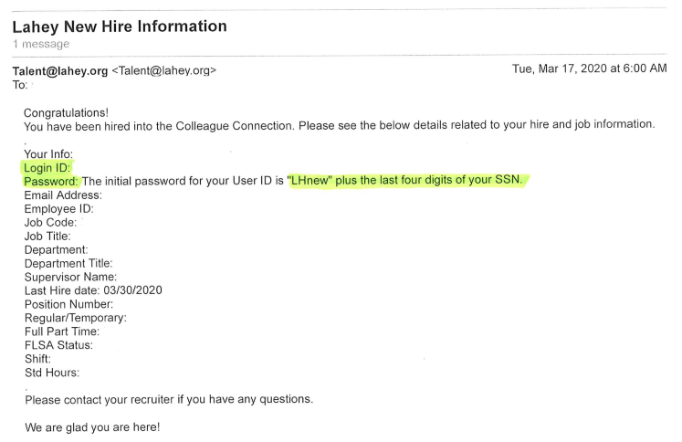
Please go to connect.lahey.org to log in. You will see this screen below:
Please use the Login ID for your User name and the temporary password provided.
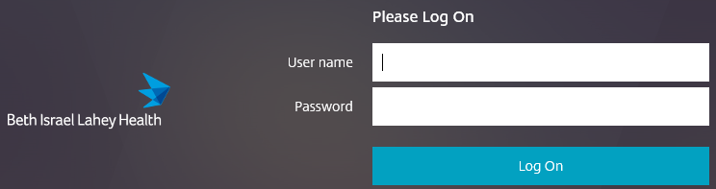
As an extra measure of security, Lahey requires use of the Duo Mobile app for offsite authentication for logging in to the system. This can be found in your mobile providers App Store and it is free to download. Please follow the Duo instructions, which are in the New Hire Packet that was attached to the email from Kara Freeburg. When you search the Duo app, it will look like this icon below:
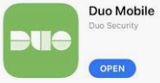

Within the New Hire Packet, you will also find instructions on how to complete your on-boarding (Benefits Enrollment, Payroll information, etc.). Please note: You will not be able to complete On-Boarding until Monday, 4/13.

